

Advanced Web engineering

AJAYA PRAJAPATI



LBU Student Id: 77262177

# Evidences of Component 3

### Project overview:

The project is created using Laravel. The auth ui is created with the help of Vue.js. In this application, there are 3 users: Guest, User and Admin. Guests can only view the lists of products. Users can add new products and Admin can edit delete and add new products. The list of books and cds are created using factories via Faker. There is only one Admin which is created using seeder.

### Index Page

Guest user can only view the lists of books and cds.

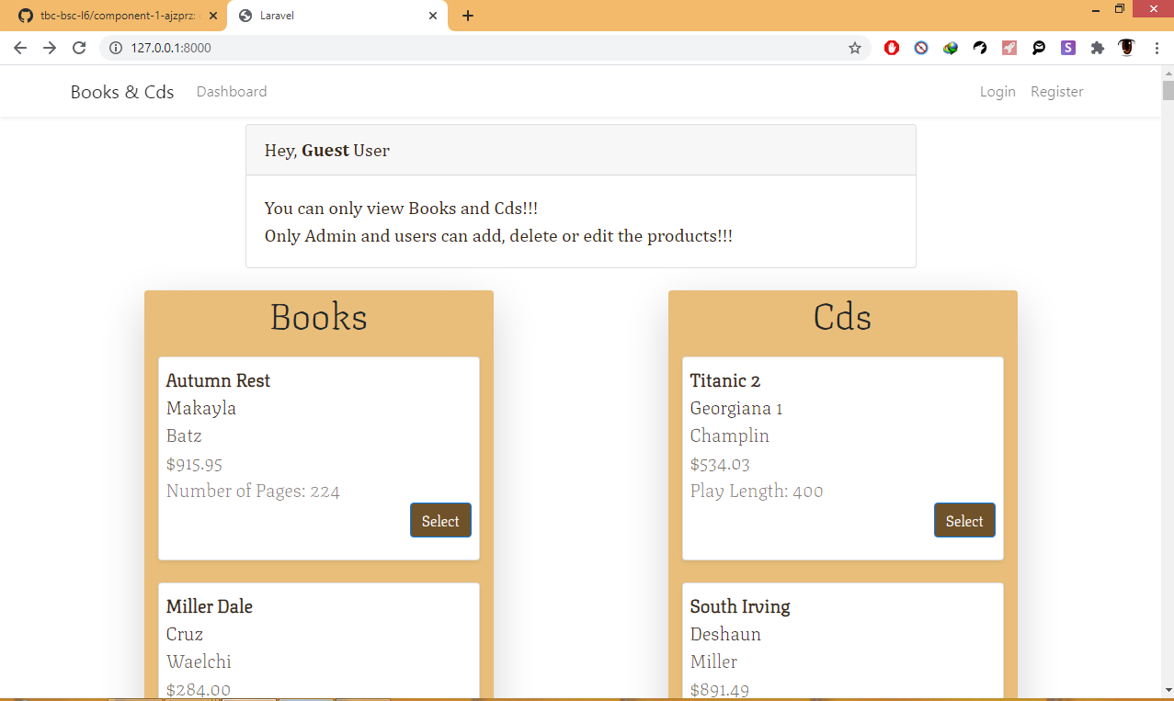

### If guest user click on select it is redirected to login page

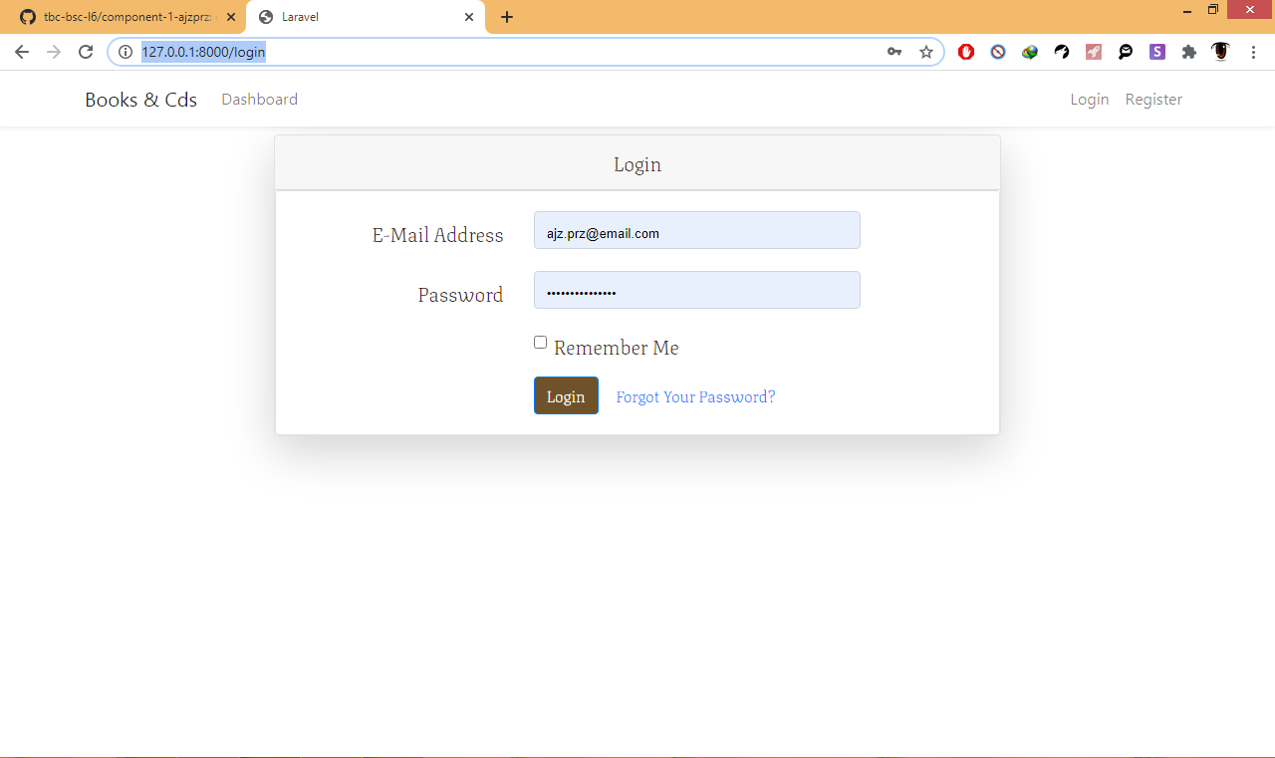

### New user Registration page

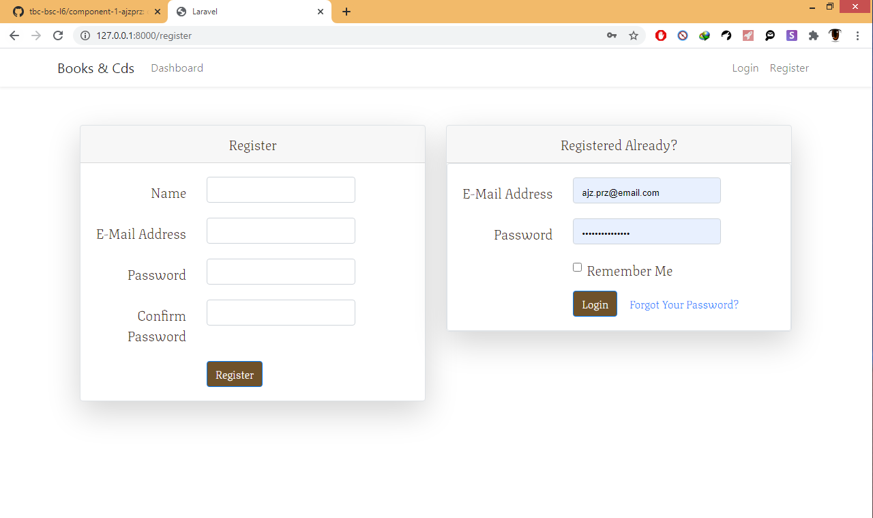

### Admin Page

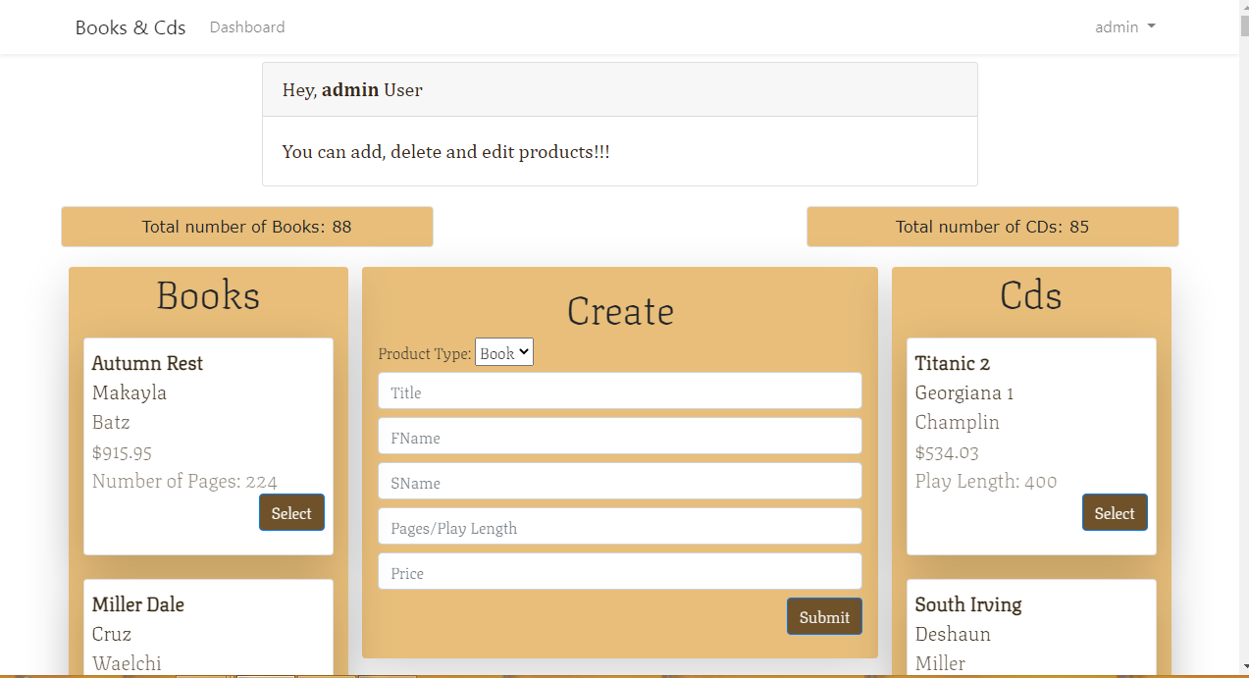

### Admin Edit Page

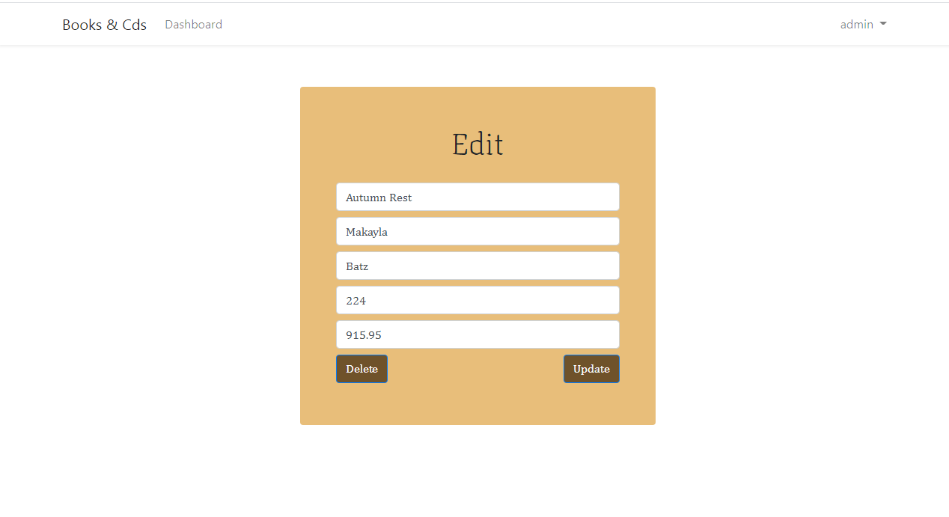

### User Page

